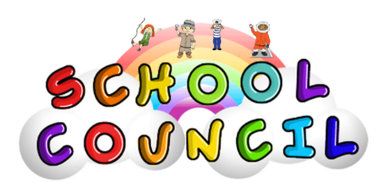

Meeting 2: Tuesday 12th December 2023

Agenda 1: Anything to be communicated?
- The councillors discussed the possibilities of new playground equipment, the Explorers were particularly excited about having a new slide for their outdoor provision area!
- The councillors have requested the return of ‘Reading Buddy’ activities. The Navigators particularly enjoyed supporting the children within their reading last year and would like the opportunity to do this again.

Agenda 2: The new tidy rota
- The school litter picking rota is up and running. All classes have made a wonderful start and many of the councillors have commented about witnessing many children taking responsibility for litter ALL of the time! Well done, Hooton Pagnell!

Agenda 3: The outdoor area
- On the 29th of November, Mrs Thorpe and Mrs Burkill met with Julia Foster, a Trees and Woodland Development Officer from Doncaster Council. Julia is working especially hard to set up a Tiny Forest within the school premises. We will be one of a few schools receiving this as a part of a making Doncaster greener scheme recommended to us by Mayor Ros Jones.
- The school council have been nominated to assist with the planning and planting process. We will continue to share any news on this as and when we can. Needless to say, this is an extremely exciting opportunity for our school, which is sure to add opportunity and beauty to the outdoor provision.

Plans for the next meeting (Thursday 18th January):
- Anything to be communicated? /Updates on agendas discussed in the previous meeting.
- Discuss feedback given from Mrs Thorpe.

To our amazing school council- thank you so much for all your hard work and wonderful ideas- you have blown us away.

To our all our lovely pupils and families of the Hooton Pagnell school community, we wish you a wonderful Christmas time and a happy New Year!

We will see you in January 2023!

