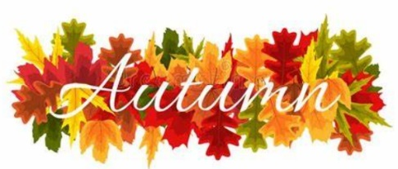
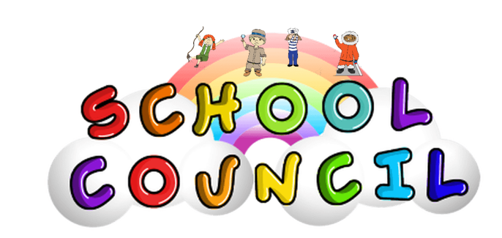

Meeting 1: Thursday 19th October
Welcome to our first school council newsletter of the year!

Introducing our new school council members:
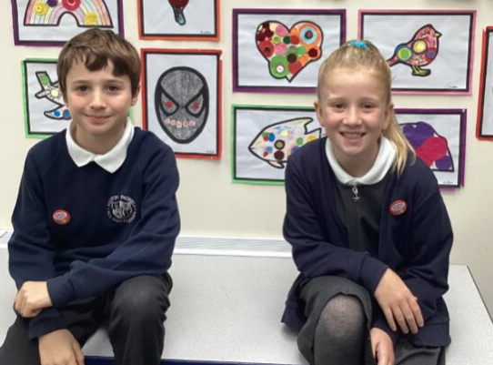
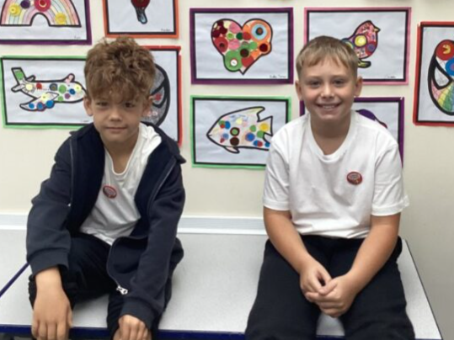

Y4 Reuben/Y3 Brody
Y6 Thomas/Y5 Poppy

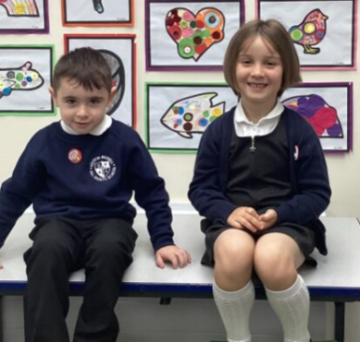
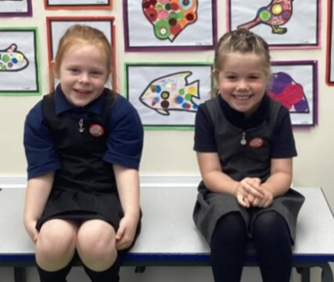
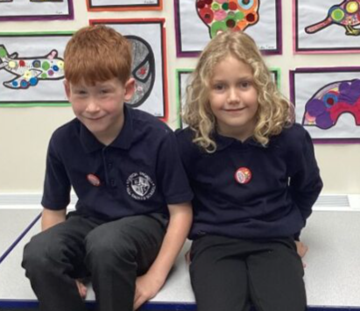

EYFS Wynter and Evelyn
Y1 Bleau and Fern
Y2 Charlie and Sienna-Rose

The elected councillors are ecstatic about their new role within school and whole-heartedly dedicate themselves to supporting their peers however possible!

Agenda 1: Welcome to School Council!
- Reminded the children of their responsibilities as members of the council.
- Passed on council recording books for each councillor to record notes.

Agenda 2: Anything to be communicated?
- The councillors have expressed a growing concern for children consistently playing near the nettles in the school field. It has been requested that I pass this on to Mr Fawcett.
- The council would like to set up another litter picking rota for this year. Mrs Burkill is going to collaborate with other staff in school in regards to this.

Plans for the next meeting (Thursday 16th November):
- Anything new to be communicated?
- Updates on agendas discussed in the previous meeting.

